TASK 5

Three phase motor connected to full-voltage magnetic reversing starter controlled by two start two forward and two reverse push button station

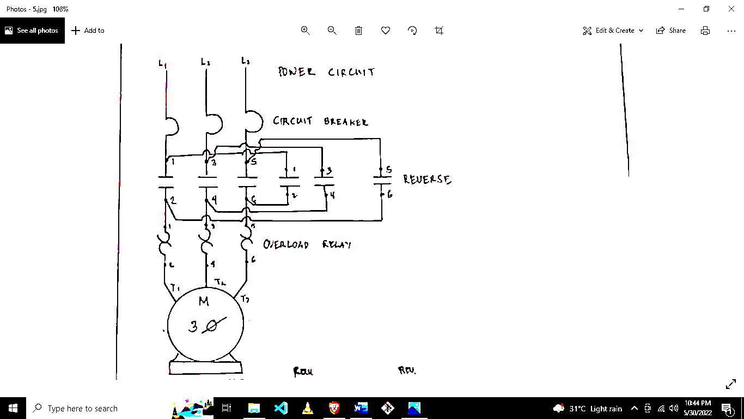

Instructor

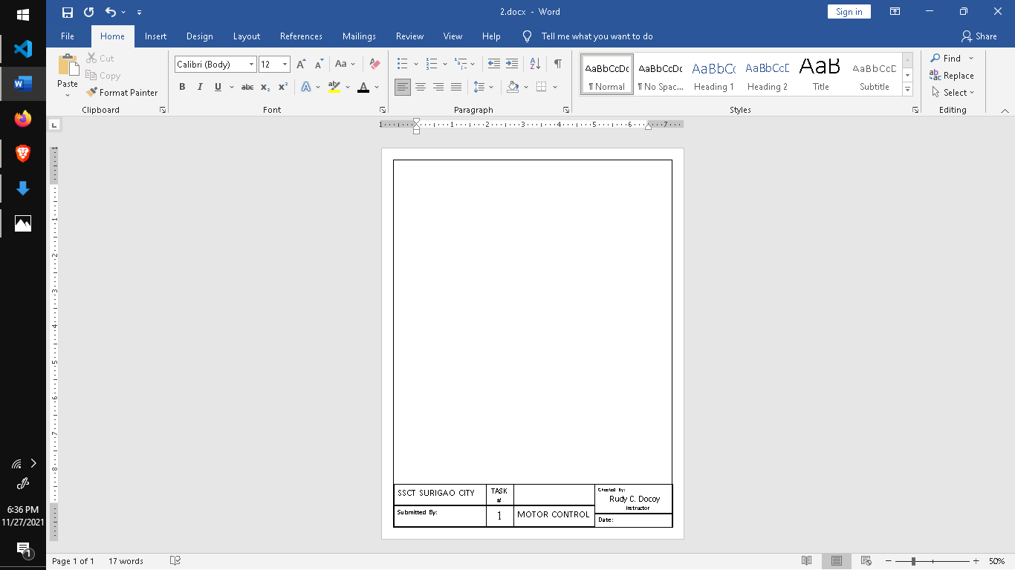

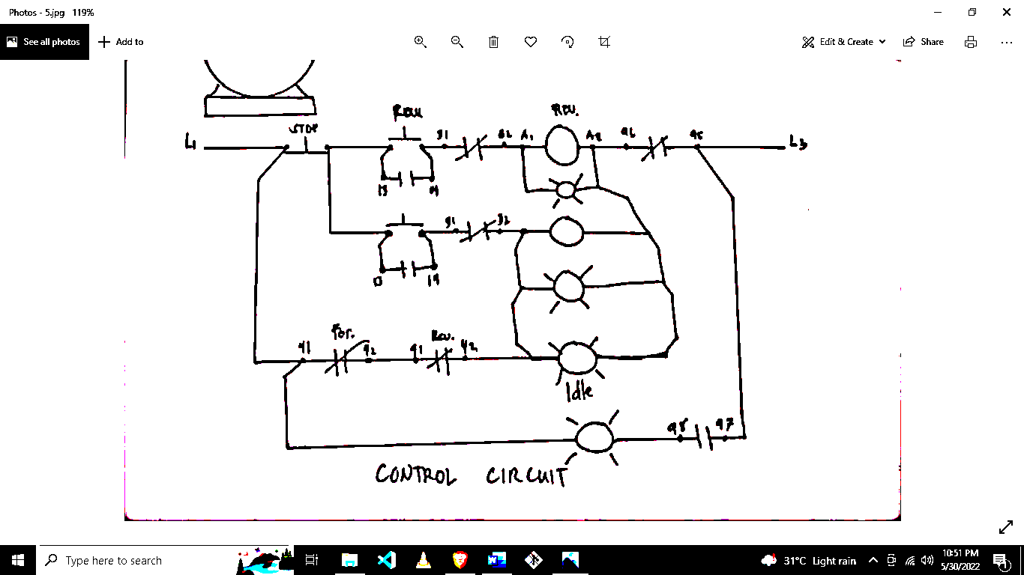



Checked By:

Rudy C. Docoy

MOTOR CONTROL

**Date :**May 31, 2022



TASK #

5

SSCT SURIGAO CITY

BEET 3C

Submitted By: